**Functional Specification Document**

**File Processing**



**Revision History**

|  |  |  |  |  |
| --- | --- | --- | --- | --- |
| Version | Purpose | Author | Reviewer | Release Date |
| V.1 | Initial Document | Parimal Gujarathi | Anant Varade | 15 Dec 2023 |
|  |  |  |  |  |

**Table of Contents**

**1.** **Introduction/Background** 4

**2.** **Functional Requirements:** 4

**2.1** **Business Need:** 4

**2.2** **High-Level Requirements:** 4

**3.** **Functional Workflow** 5

**3.1** **High-Level Diagram** 5

**3.2** **Detailed Functional Requirements** 6

**4.** **Key Assumptions & Dependencies** 7

**5.** **Inputs** 7

**5.1** **Pre-requisites:** 7

**5.2 Inputs Required:** 7

**6.** **Exceptions Handling** 8

**7.** **Out of Scope for RPA** 8

# **Introduction/Background**

Demo Bank is multi state/multi scheduled bank. Bank having large no of loan applications of different loan products like home loans, agriculture loans, car/vehicle loans.

Loan officers are sending loan documents in email to centralize team for document segregation and protecting PDF files with password.

Bank is looking for automated solution to read emails and segregate documents based on document type. Bank is looking to standardize image files to JPEG format and PDF file need to be protected with password. Centralize team needs to send zip file of segregated documents & upload status report on google drive.

This document covers functional specification of the current process being followed by the users.

# **Functional Requirements:**

## **Business Need:**

Develop solution to read email from inbox with specific subject. Download attachments from received email. Standardize image files by converting different image formats in JPEG format. Protect PDF file with password. Zip & Send converted files and password protected files to client in email.

Proposed solution will create status report for original file details and converted file details, PDF file and password of pdf file.

Proposed solution needs to create excel log file for processed email details.

## **High-Level Requirements:**

1. Read email with subject "Reference Documents"
2. Log email details subject, sender, date, email body in excel sheet
3. Download attachments if any in the email and save in a separate folder
4. Check if attachment is image, convert image to specific extension, if attachment is pdf apply password for pdf.
5. Compress folder containing converted image, password protected files and other files and email to client.
6. Update status report on Google drive.

# **Functional Workflow**

## **High-Level Diagram**

This section covers high level functional flow of File processing functionality being covered in the scope.

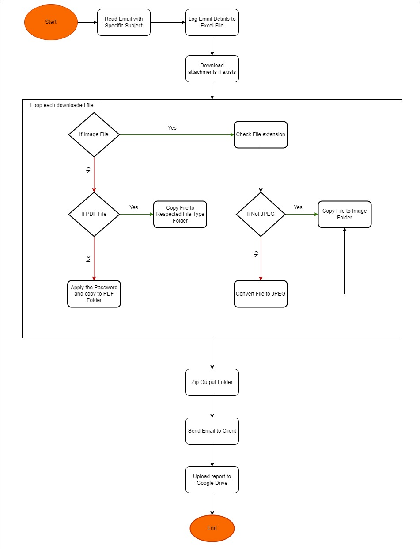

## **Detailed Functional Requirements**

**Step 1:** Open Mailbox

<<Typically there will be screen shot of the screen along with highlighted fields for all steps. A sample is provided here for 1 step>>

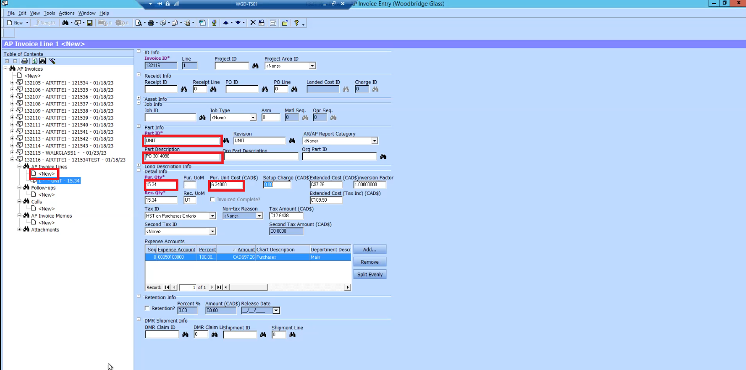

**Step 2:** Check all unread emails received today.

**Step 3:** Select emails with subject line "Reference Documents"

**Step 4:** Check if email log file is existing in folder

**Step 5:** Extract email information like subject, sender, date, email body in excel sheet

**Step 6:** if email comes without attachment then add entry in excel file

**Step 7:** Download all attachments in temporary folder

**Step 8:** Separate out documents based on extension (Image, PDF, Word Documents, Excel Documents, etc.)

**Step 9:** Convert image files in jpeg file format if image is in other format

**Step 10:** Add record in excel file with original file name & extension and converted file and extension

**Step 11:** Add password to pdf file

**Step 12:** Add record in excel file with pdf file name and password

**Step 13:** Create Zip file of Image and PDF files and send email with Attachment and excel file.

**Step 14:** Update status report on google drive

# **Key Assumptions & Dependencies**

Following are the dependencies to run automated solution:

1. Email account access to read email and download attachments.
2. Local drive access to perform file operations. E.g. file copy, file creation etc.
3. Google drive access to copy status report.

The following assumptions are made while the development of automated solution:

1. No filters added on Inbox.
2. All unread emails received on same day are consider.
3. Considering maximum 200 MB total file size.
4. Emails are filtered based on Subject line and from any sender.
5. Only selected file formats are considered (JPEG, JPG, PNG, TIFF, DOC, DOCX, XLS, XLSX, PPT, PPTX, PDF, TXT).
6. Proposed solution will run in 15 min time interval.

# **Inputs**

## **Pre-requisites:**

1. Email account access.
2. Access to local drive to perform file operations.
3. Access to Google drive.

## **5.2 Inputs Required:**

1. Email ID and Password to access Inbox.

# **Exceptions Handling**

Proposed solution should have mechanism to handle exceptions and logged errors generated during process execution. Error logging is expected in text file which developer will refer for adding exception handling scenarios in solution.

1. File size limit exceeded
2. Insecure attachments (e.g. Zip file or Executable files)
3. Inbox not accessible.
4. Invalid client’s email id.
5. Google drive is not accessible.

# **Out of Scope for RPA**

1. Unread emails from previous day with “Reference Document” subject line are not considered.
2. Emails move to other folders (e.g. Junk, Deleted etc.) are not considered.
3. Password protected files are not considered for conversion. Such files are copied as is into output folder.
4. Document archival is not consider in current development scope.